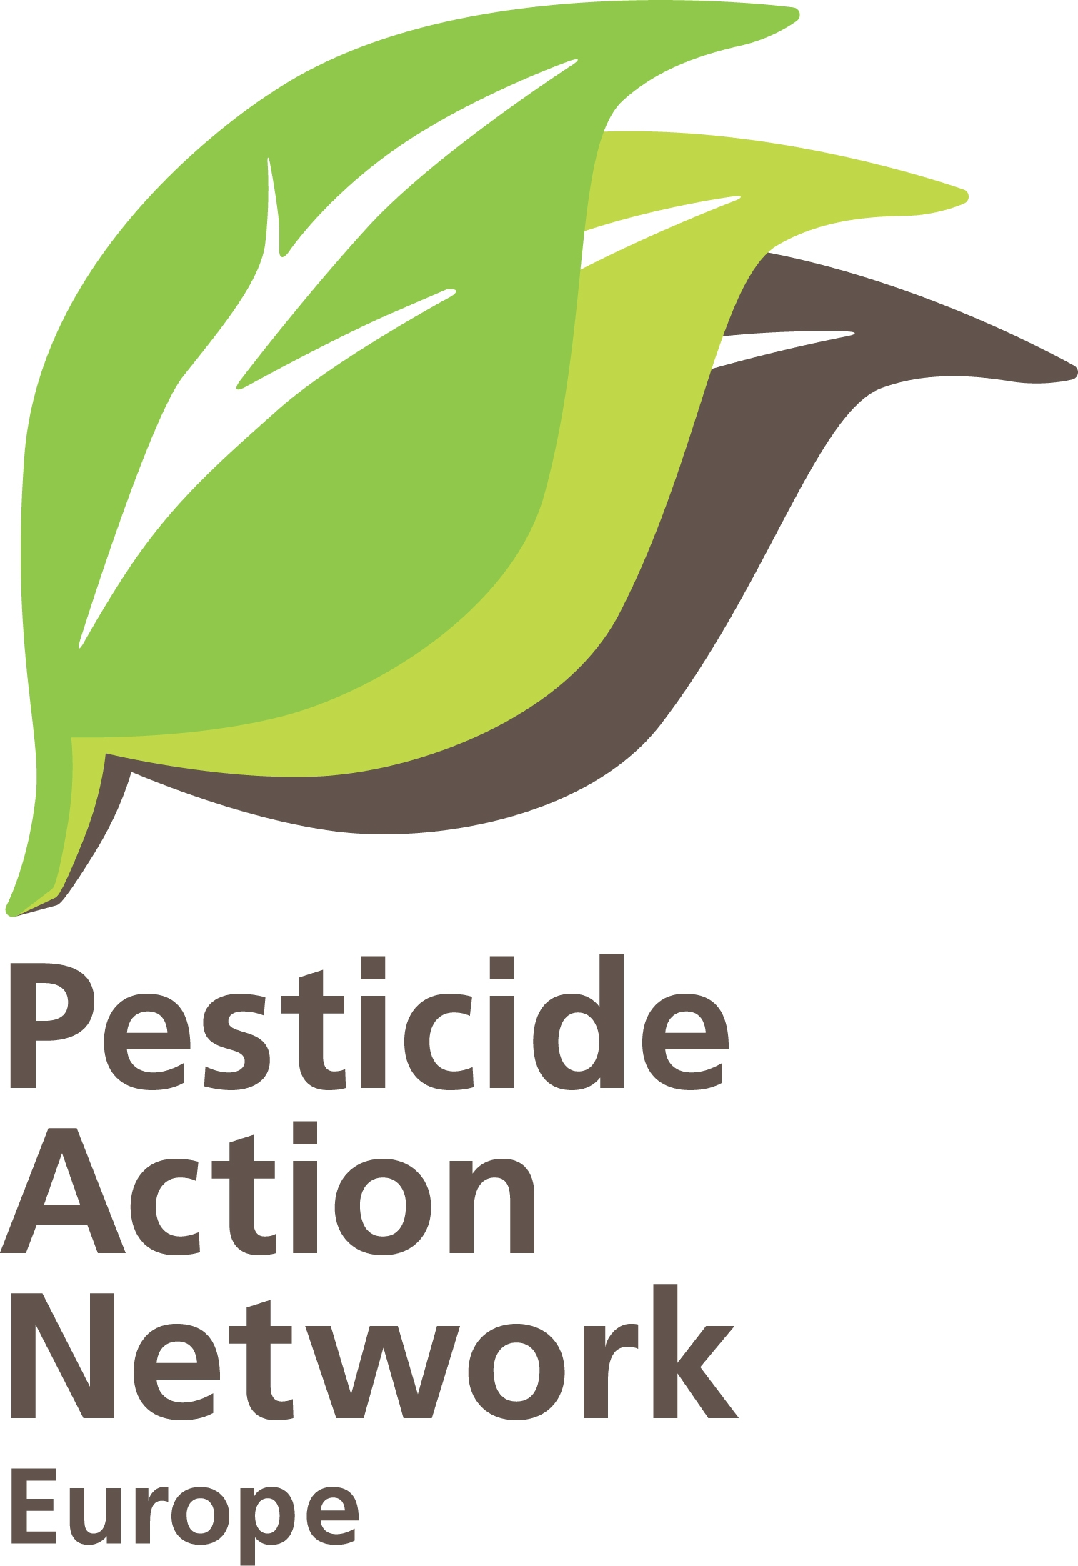 ‘a radical change in food consumption and production in Europe is unavoidable to meet the challenges of scarcities and to make the European agro-food system more resilient in times of increasing instability and surprise.
the SCAR 3rd Foresight report

Brussels, 30 September 2011

PAN Europe’s answers to the Consultation on the Green paper on promotion measures and information provision for agricultural products

Who are we: Pesticide Action Network Europe (PAN Europe) is a network of NGOs organisations working to minimise negative effects and replace the use of hazardous chemicals with ecologically sound alternatives.
Our network brings together consumer, public health, and environmental organisations, women's and farm advisory groups from across 19 European countries.
We work to eliminate dependency on chemical pesticides and to support safe sustainable pest control methods.

Added value of EU intervention
1. To meet the new challenges in local, European and global markets and ensure the greatest possible added value for Europe, what should the aims of the agricultural product information and promotion policy be? In addition to measures already taken by other players (e.g. the private sector), what contribution should this policy make?
The SCAR 3rd Foresight report highlights that a radical change in food consumption and production in Europe is unavoidable to meet the challenges of scarcities and to make the European agro-food system more resilient in times of increasing instability and surprise.

Information measures and promotion programs should be redesigned to reflect these challenges.

The aim of the information and promotion policy should be starting with providing information on production methods, and aim at creating long lasting links between citizens, consumers and agricultural production.

This approach also seems highlighted in the consultation document on the CAP towards 2020 (……) which on page 10 states:

‘Consumers and stakeholders do not seem to be sufficiently well informed about the characteristics and production methods that define the quality of products, with information and promotion activities becoming an important marketing tool.’
Environment and consumer organisations can help to create more diversification, and as a result more diversification in prices, along the food chain too.

The focus should be on making the EU citizens/consumers understand the complexity of the agricultural sector, make the citizens discover the importance of agricultural methods, and make citizens/consumers realise that the agricultural sector can both be a problem and a solution in overcoming the environmental and health dégradation.

Regional and local markets

2. What information and promotion measures should be put in place to develop stronger local and regional markets?
Ensuring local involvement : Information and promotion measures to put in place at the local and régional level should start with involving citizens in EU farming, with the purpose of increase awareness of the importance of HOW agricultural products are produced, and how sustainable agricultural methods is of importance in providing environmental and public health benefits/problems.
Ex : invite local groups of citizens to measure biodiversity in the farmers field. Farms open to the public.

Establish a EU programme to test residue levels: EU citizens continue to consider pesticides residue levels in fruit, vegetables and cereals as their main concern regarding food related risks (special Eurobarometer 354, November 2010).
As part of the information and promotion measures, it would be worth considering in collaboration with DG SANCO for the EU to establish a testing programme, allowing an independent body test pesticide residue levels across the EU.

Promotion in the internal market
3. What are the specific needs in relation to information on and promotion of European products and what should the aims be in the internal market?

EU citizens are concerned about farmers pesticide dependency: EU citizens continue to consider pesticides residue levels in fruit, vegetables and cereals as their main concern regarding food related risks (special Eurobarometer 354, November 2010).

EU citizens are concerned about environment protection: EU citizens believe that environmental protection needs to be an element of the Common Agricultural Policy (Special Eurobarometer 336, March 2010).

Production methods need to be explicitly targeted in the information and promotion measures targeted EU citizens.

4. What measures should be developed to achieve the aims set and thus optimise the European Union’s intervention in the internal market?
The European agricultural sector is becoming more and more standardised, raw material is becoming a standard product, and the importance on how the raw material is being produced is being set aside by the industry. We believe that it is time for a paradigm change in the agricultural sector, to make sure that production methods is again getting at the centre of any policy, including the measures for promotion and information.

Special Eurobarometer 354, November 2010 on food risks includes a survey on Public confidence in sources of information on food safety. The survey shows that EU citizens are the most confident in “their physician/doctor”, “family and friends” and then “consumer organisations” (76%), “scientists” (73%) and “environmental protection groups” (71%). The wide majority of Europeans feel confident about “farmers” (58%) with respect to information on food risks. These are the only actors in the food supply chain that reach a level of confidence above 50%. Results show that respondents tend to trust information from those involved in the food supply chain to a much lower degree, with about a third saying they feel confident about information from “food manufacturers” (35%) and “retailers” (36%).

To optimise the EU’s intervention in the internal market, there is a need to seriously consider involving NGOs as equal partners able to help ensuring the needed diversification in the food chain.

Promotion in the external market
5. What are the specific needs in terms of information on and promotion of European products and what should the aims be in the external market?
It seems difficult to expect that consumers outside the EU will be interesting in potential environmental protection that has been taken when producing the product in the EU.
Though, it seems very likely that consumers outsider the EU will be interesting in buying products which are healthier to them to eat, for instance which lower level of pesticides residues.

6. What measures should be developed to achieve the aims set and thus optimise the European Union’s intervention in the external market?
As part of the information and promotion measures, it would be worth considering in collaboration with DG SANCO for the EU to establish a testing programme, allowing an independent body test pesticide residue levels across the EU. This could be an important marketing tool on the external market.

Beneficiaries
7. Who should benefit? Should priority be given to certain beneficiaries?
Special Eurobarometer 354, November 2010 does not only identify that EU citizens’ views on food risks it also includes a survey on Public confidence in sources of information on food safety. The survey shows that EU citizens are the most confident in “their physician/doctor”, “family and friends” and then “consumer organisations” (76%), “scientists” (73%) and “environmental protection groups” (71%). The wide majority of Europeans feel confident about “farmers” (58%) with respect to information on food risks. These are the only actors in the food supply chain that reach a level of confidence above 50%. Results show that respondents tend to trust information from those involved in the food supply chain to a much lower degree, with about a third saying they feel confident about information from “food manufacturers” (35%) and “retailers” (36%).

Priorities should be giving to groups that citizens trust, as that is the most cost efficent instrument.

Synergies with other CAP instruments

8. In order to develop more effective and more ambitious strategies for accessing local, European and global markets, are there any conceivable synergies between the various promotion and information tools available to the EU?
N/A

Eligible products
9. Which agricultural and agri-food products should be eligible and what criteria should be used to decide
N/A

Actions and messages
10. To be more incisive, which means of promotion should be used? Should the focus be on promoting key messages, such as ‘5 portions of fruit and vegetables a day’ or ‘the taste of Europe’, or on product ranges (such as cheese, wine, etc.)?
The message should be as specific as possible, to make sure that the message target right.
General messages, and any message aiming at green washing must be avioded.

Origin
11. Would it be appropriate to provide more space for the indication of origin of the product and what criteria should be used to decide?
N/A
Brands
12. Would it be appropriate to use brands as a promotion tool in the external market and what criteria should be used to decide?
No

Multi country programmes
13. What is stopping the presentation and implementation of Multi-country programmes? What would need to be done to encourage these programmes with a greater European dimension?
N/A

14. Do any other types of programmes and/or tools need to be developed?
Yes, PAN Europe proposes a promotion policy in the EU should consider establishing an EU residue programme, testing pesticides residues, and use this as a marketing tool at both, regional, national and international market.

Implementation
15. How can the selection and implementation of programmes be simplified and improved?
Special Eurobarometer 354, November 2010 includes a survey on Public confidence in sources of information on food safety, showing that there are big differences between who EU citizens trust.

There are so many brands, and so many messages are giving regarding what is good and bad for consumers to eat. A simple was to increase transparency in the market would be to include NGOs fully into marketing campaigns.
This procedure is starting in certain member states, as for instance Denmark where certain adds has an environmental logo at the end, the ombudsman has made guidelines on what is green washing and what is not, it would be good for the EU to get inspired by this model.

General comments
16. Participants are invited to raise any questions concerning the information and promotion policy for agricultural products that have not been covered in this document.
Like raised in other answers, it is important to fully recognise NGOs as partners in the food chain, also regarding promotion and information measures. Tghough, it is also important to keep in mind that cofinancing rules for NGOs need to be keps low as they have very low level of funding, with no possibility of establishing a reserve.

17. From your point of view, what is the importance of the following aspects of promotion of agricultural products on the EU level?

 | 1 - most important | 2 - important | 3 - somewhat important | 4 - not important | 5 - no opinion
Support for regional and local markets* (compulsory) | Most importnat
Internal market promotion* (compulsory) | Most important
External market promotion* (compulsory) | Not important
Synergy between different CAP promotion instruments* (compulsory) | Important
Eligibility of products* (compulsory) | Important
Definition of eligible actions and messages* (compulsory) | Very important
Promotion of origin* (compulsory) | Important
Brand promotion* (compulsory) | Not important
Priority for multi country programmes* (compulsory) | ?
Procedures for selection and implementation of co-financed programmes* (compulsory) | ?
For further information:
Henriette Christensen, senior policy advisor, PAN Europe Brussels office
tel: + 32 2 503 08 37; email: henriette@pan-europe.info

Pesticide Action Network Europe (PAN Europe) was founded in 1987 and brings together consumer, public health, and environmental organisations, trades unions, women's groups and farmer associations from across 19 European countries. PAN Europe is part of the global network PAN working to minimise the negative effects and replace the use of harmful pesticides with ecologically sound alternatives.

Number in the EU register of interested parties : 15913213485-46

European Commission – Standing Committee on Agricultural Research (SCAR), The 3rd SCAR Foresight Exercise (2011) Sustainable food consumption and production in a resource-constrained world.

